Table of Contents
Setting up a full-stack React project 2
Creating the user interface for our application 4
Component structure 5
Implementing static React components 7
The Post component 7
The CreatePost component 9
The PostFilter and PostSorting components 10
The PostList component 11
Putting the app together 14
Integrating the backend service using TanStack Query 15
Setting up TanStack Query for React 16
Fetching blog posts 17
Implementing filters and sorting 19
Creating new posts 22

Setting up a full-stack React project

Before we can start developing our frontend application, we first need to merge our previously created frontend boilerplate based on Vite with the backend service created in Chapter 3, Implementing a Backend Using Express, Mongoose ODM, and Jest. Let’s merge them now by following these steps:

1. Copy the ch1 folder to a new ch4 folder, as follows:
$ cp -R Ch01 Ch04

2. Copy the ch3 folder to a new ch4/backend folder, as follows:
$ cp -R Ch03 Ch04/backend

3. Delete the .git folder in the copied ch4/backend folder, as follows:
$ rm -rf ch4/backend/.git

4. Open the new ch4 folder in VS Code.
5. Remove the Husky prepare script (the line is highlighted in the code snippet) from the backend/package.json file, as we already have Husky set up in the root directory:
"scripts": {
"dev": "vite",
"build": "vite build",
"lint": "eslint .",
"preview": "vite preview",
"prepare": "husky install"
}

6. Also remove the following lint-staged config from the backend/package.json file:
"lint-staged": {
"**/*.{js,jsx}": [
"npx prettier --write",
"npx eslint --fix"
]
}

7. Then, remove the backend/.husky, backend/.vscode, and backend/.git folders.
8. To make sure all dependencies are installed properly, run the following command in the root of the ch4 folder:
$ npm install

9. Also go to the backend/ directory and install all dependencies there:
$ cd backend/
$ npm install

10. We can now also remove the husky, lint-staged, and @commitlint packages from the backend project, as we already have it set up in the main project folder:
$ npm uninstall husky lint-staged \
@commitlint/cli @commitlint/config-conventional
Tip
It is always a good idea to regularly check which packages you still need and which you can get rid of, to keep your project clean. In this case, we copied code from another project, but do not need the Husky / lint-staged / commitlint setup, as we already have it set up in the root of our project.

11. Now go back to the root of the ch4 folder and run the following command to start the frontend server:
$ cd ../
$ npm run dev

12. Open the frontend in your browser by going to the URL shown by Vite: http://localhost:5173/
13. Open src/App.jsx, change the title as follows, and save the file:
<h1>Vite + React + Node.js</h1>

14. You will see that the change is reflected instantly in the browser!

After successfully setting up our full-stack project by combining our projects from previous chapters, let’s now get started designing and creating the user interface for our blog application.

Creating the user interface for our application

When designing the structure of a frontend, we should also consider the folder structure, so that our app can grow easily in the future. Similar to how we did for the backend, we will also put all our source code into a src/ folder. We can then group the files in separate folders for the different features. Another popular way to structure frontend projects is to group code by routes. Of course, it is also possible to mix them, for example, in Next.js projects we can group our components by features and then create another folder and file structure for the routes, where the components are used. For full-stack projects, it additionally makes sense to first separate our code by creating separate folders for the API integration and UI components.

Now, let’s define the folder structure for our project:
- Create a new src/api/ folder.
- Create a new src/components/ folder.

Tip
It is a good idea to start with a simple structure at first, and only nest more deeply when you actually need it. Do not spend too much time thinking about the file structure when starting a project, because usually, you do not know upfront how files should be grouped, and it may change later anyway.

After defining the high-level folder structure for our projects, let’s now take some time to consider the component structure.

Component structure

Based on what we defined in the backend, our blog application is going to have the following features:

- Viewing a single post
- Creating a new post
- Listing posts
- Filtering posts
- Sorting posts

The idea of components in React is to have each component deal with a single task or UI element. We should try to make components as fine-grained as possible, in order to be able to reuse code. If we find ourselves copying and pasting code from one component to another, it might be a good idea to create a new component and reuse it in multiple other components.

Usually, when developing a frontend, we start with a UI mock-up. For our blog application, a mock-up could look as follows:

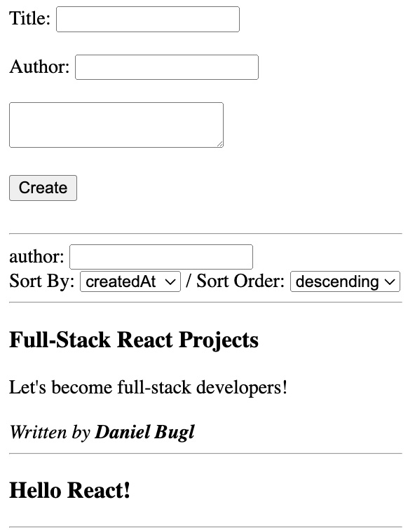

When splitting up the UI into components, we use the single-responsibility principle, which states that every module should have responsibility over a single encapsulated part of the functionality.

In our mock-up, we can draw boxes around each component and subcomponent, and give them names. Keep in mind that each component should have exactly one responsibility. We start with the fundamental components that make up the app:

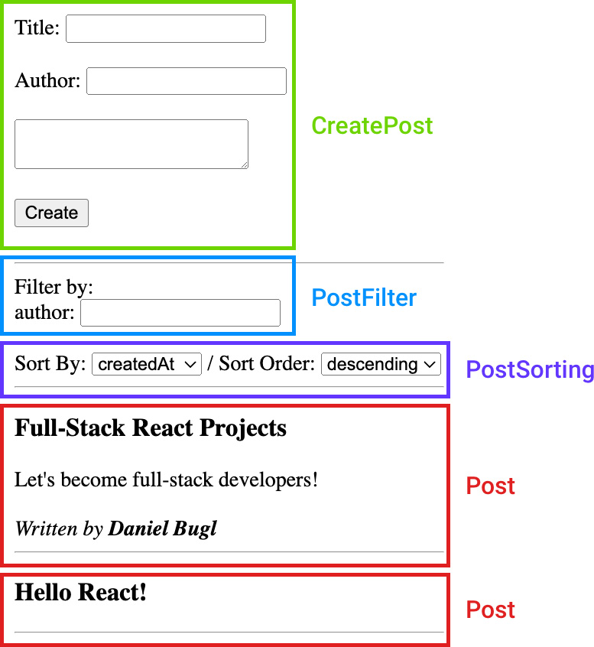

We defined a CreatePost component, with a form to create a new post, a PostFilter component to filter the list of posts, a PostSorting component to sort posts, and a Post component to display a single post.

Now that we have defined our fundamental components, we are going to look at which components logically belong together, thereby forming a group: we can group the Post components together in PostList, then make an App component to group everything together and define the structure of our app.

Now that we are done with structuring our React components, we can move on to implementing the static React components.

Implementing static React components

Before integrating with the backend, we are going to model the basic features of our application as static React components. Dealing with the static view structure of our application first makes sense, as we can play around and re-structure the application UI if needed, before adding integration to the components, which would make it harder and more tedious to move them around. It is also easier to deal only with the UI first, which helps us to get started quickly with projects and features. Then, we can move on to implementing integrations and handling state.

Let’s get started implementing the static components now.

The Post component

We have already thought about which elements a post has during the creation of the mock-up and the design of the backend. A post should have a title, contents, and an author.

Let’s implement the Post component now:

1. First, create a new src/components/Post.jsx file.
2. In that file, import PropTypes:
import PropTypes from 'prop-types';

3. Define a function component, accepting title, contents, and author props:
export function Post({ title, contents, author }) {

4. Next, render all props in a way that resembles the mock-up:
return (
<article className="post">
<h3>{title}</h3>
<div>{contents}</div>
{author && (
<em>
<br />
Written by:<strong>{author}</strong>
</em>
)}
</article>
);
}

Please note that you should always prefer spacing via CSS, rather than using the <br /> HTML tag. However, we are focusing on the UI structure and integration with the backend in this book, so we simply use HTML whenever possible.

5. Now, define propTypes, making sure only title is required:
Post.propTypes = {
title: PropTypes.string.isRequired,
contents: PropTypes.string,
author: PropTypes.string,
};

Info
PropTypes are used to validate the props passed to React components and to ensure that we are passing the correct props when using JavaScript. When using a type-safe language, such as TypeScript, we can instead do this by directly typing the props passed to the component.

6. Let’s test out our component by replacing the src/App.jsx file with the following contents:
import { Post } from "./components/Post.jsx";

export function App() {

return (
<Post
title="My First Post"
contents="This is the contents of my first post."
author="John Doe"
/>
);
}

7. Edit src/main.jsx and update the import of the App component, because we are now not using export default anymore:
import { App } from "./App.jsx";

Info
I personally tend to prefer not using default exports, as they make it harder to re-group and re-export components and functions from other files. Also, they allow us to change the names of the components, which could be confusing. For example, if we change the name of a component, the name when importing it is not changed automatically.

8. Also, remove the following line from src/main.jsx:
import './index.css'

9. Finally, we can delete the index.css and App.css files, as they are not needed anymore.

Now that our static Post component has been implemented, we can move on to the CreatePost component.

The CreatePost component
We’ll now implement a form to allow for the creation of new posts. Here, we provide fields for author and title and a <textarea> element for the contents of the blog post.

Let’s implement the CreatePost component now:

1. Create a new src/components/CreatePost.jsx file.
2. Define the following component, which contains a form to enter the title, author, and contents of a blog post:
export function CreatePost() {
return (
<form onSubmit={(e) => e.preventDefault()}>
<div>
<label htmlFor="create-title">Title:</label>
<input type="text" id="create-title" name="create-title" required />
</div>
<br />
<div>
<label htmlFor="create-author">Author: </label>
<input type="text" id="create-author" name="create-author" />
</div>
<br />
<textarea
id="create-contents"
name="create-contents"
rows="5"
cols="30"
placeholder="Write your post contents here..."
></textarea>
<br />
<br />
<input type="submit" value="Create" />
</form>
);
}

In the preceding code block, we defined an onSubmit handler and called e.preventDefault() on the event object to avoid a page refresh when the form is submitted.

3. Let’s test the component out by replacing the src/App.jsx file with the following contents:
import { createPost } from "./components/CreatePost.jsx";

export function App() {
return <createPost />;
}

As you can see, the CreatePost component renders fine. We can now move on to the PostFilter and PostSorting components.
Tip
If you want to test out multiple components at once and keep the tests around for later, or build a style guide for your own component library, you should look into Storybook (https://storybook.js.org), which is a useful tool to build, test, and document UI components in isolation.

The PostFilter and PostSorting components

Similar to the CreatePost component, we will be creating two components that provide input fields to filter and sort posts. Let’s start with PostFilter:

1. Create a new src/components/PostFilter.jsx file.
2. In this file, we import PropTypes:
import PropTypes from 'prop-types'

3. Now, we define the PostFilter component and make use of the field prop:
import PropType from "prop-types";
export function PostFilter({ field }) {
return (
<div>
<label htmlFor={`filter-${field}`}>{field}</label>
<input
type="text"
id={`filter-${field}`}
name={`filter-${field}`}
placeholder={`Filter by ${field}`}
onChange={(e) => onFilterChange(e.target.value)}
/>
</div>
);
}

PostFilter.propTypes = {
field: PropType.string.isRequired,
onFilterChange: PropType.func.isRequired,
};

Next, we are going to define the PostSorting component.

4. Create a new src/components/PostSorting.jsx file.

5. In this file, we create a select input to select which field to sort by. We also create another select input to select the sort order:
import PropTypes from "prop-types";
export function PostSorting({ fields = [] }) {
return (
<div>
<label htmlFor="sortBy">Sort By: </label>
<select id="sortBy" name="sortBy">
{fields.map((field) => (
<option key={field} value={field}>
{field.charAt(0).toUpperCase() + field.slice(1)}
</option>
))}
</select>
{" / "}
<label htmlFor="sortOrder">Sort Order: </label>
<select id="sortOrder" name="sortOrder">
<option value={"ascending"}>Ascending</option>
<option value={"descending"}>Descending</option>
</select>
</div>
);
}

PostSorting.propTypes = {
fields: PropTypes.arrayOf(PropTypes.string).isRequired,
};

Now we have successfully defined UI components to filter and sort posts. In the next step, we are going to create a PostList component to combine the filter and sorting with a list of posts.

The PostList component
After implementing the other post-related components, we can now implement the most important part of our blog app, that is, the feed of blog posts. For now, the feed is simply going to show a list of blog posts.

Let’s start implementing the PostList component now:

1. Create a new src/components/PostList.jsx file.
2. First, we import Fragment, PropTypes, and the Post component:
import { Fragment } from "react";
import PropTypes from "prop-types";
import { Post } from "./Post.jsx";

3. Then, we define the PostList function component, accepting a posts array as a prop. If posts is not defined, we set it to an empty array, by default:
export function PostList({ posts = [] }) {

4. Next, we render all posts by using the .map function and the spread syntax:
return (
<div>
{posts.map((post) => (
<Post {...post} key={post.id} />
))}
</div>
);

We return the <Post> component for each post, and pass all the keys from the post object to the component as props. We do this by using the spread syntax, which has the same effect as listing all the keys from the object manually as props, like so:
<Post
title={post.title}
author={post.author}
contents={post.contents}
/>

Note
If we are rendering a list of elements, we have to give each element a unique key prop. React uses this key prop to efficiently compute the difference between two lists when the data has changed.

We used the map function, which applies a function to all the elements of an array. This is similar to using a for loop and storing all the results, but it is more concise, declarative, and easier to read! Alternatively, we could do the following instead of using the map function:
let renderedPosts = [];
let index = 0;
for (let post of posts) {
renderedPosts.push(<Post {...post} key={post._id} />);
index++;
}
return <div>{renderedPosts}</div>;

However, using this style is not recommended with React.

5. We also still need to define the prop types. Here, we can make use of the prop types from the Post component, by wrapping it inside the PropTypes.shape() function, which defines an object prop type:
PostList.propTypes = {
posts: PropTypes.arrayOf(PropTypes.shape(Post.propTypes).isRequired),
};

6. In the mock-up, we have a horizontal line after each blog post. We can implement this without an additional <div> container element, by using Fragment, as follows:
return (
<div>
{posts.map((post) => (
<Fragment key={post.id}>
<Post {...post} />
<hr />
</Fragment>
))}
</div>
);

Note
The key prop always has to be added to the uppermost parent element that is rendered within the map function. In this case, we had to move the key prop from the Post component to Fragment.

7. Again, we test our component by editing the src/App.jsx file:
import { PostList } from './components/PostList.jsx'
import { PostList } from "./components/PostList.jsx";
const posts = [
{
title: "Full-Stack React Projects",
contents: "Let's become full-stack developers!",
author: "Daniel Bugl",
},
{
title: "Hello React!",
contents: "This is my first post in this book.",
author: "Roland Klahitar",
},
];

export function App() {
return <PostList posts={posts} />;
}

Now we can see that our app lists all the posts that we defined in the posts array.

As you can see, listing multiple posts via the PostList component works fine. We can now move on to putting the app together.

Putting the app together

After implementing all the components, we now have to put everything together in the App component. Then, we will have successfully reproduced the mock-up!

Let’s start modifying the App component and putting our blog app together:

1. Open src/App.jsx and add imports for the CreatePost, PostFilter, and PostSorting components:
import { CreatePost } from "./components/CreatePost.jsx";
import { PostFilter } from "./components/PostFilter.jsx";
import { PostSorting } from "./components/PostSorting.jsx";

2. Adjust the App component to contain all the components:
export function App() {
return (
<div style={{ padding: 8 }}>
<CreatePost />
<br />
<hr />
Fiter by:
<PostFilter field="author" />
<br />
<PostSorting fields={["createdAt", "updatedAt"]} />
<hr />
<PostList posts={posts} />
</div>
);
}

3. After saving the file, the browser should automatically refresh, and we can now see the full UI:
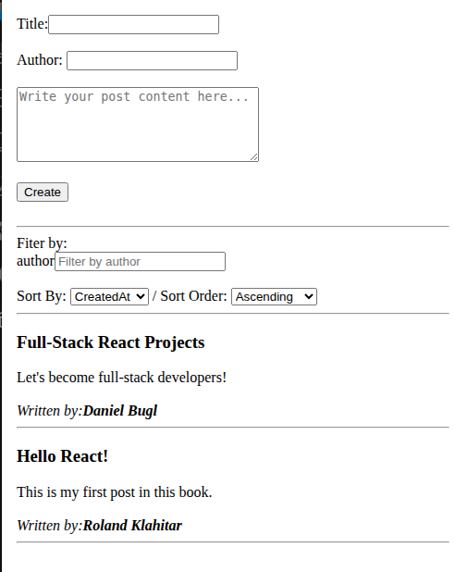

As we can see, all of the static components that we defined earlier are rendered together in one App component. Our app now looks just like a mock-up. Next, we can move on to integrating our components with the backend service.

Integrating the backend service using TanStack Query

After finishing creating all the UI components, we can now move on to integrating them with the backend we created in the previous chapter. For the integration, we are going to use TanStack Query (previously called React Query), which is a data fetching library that can also help us with caching, synchronizing, and updating data from a backend.

TanStack Query specifically focuses on managing the state of fetched data (server state). While other state management libraries can also deal with server state, they specialize in managing client state instead. Server state has some stark differences from client state, such as the following:

- Being persisted remotely in a location the client does not control directly
- Requiring asynchronous APIs to fetch and update state
- Having to deal with shared ownership, which means that other people can change the state without your knowledge
- State becoming stale (“out of date”) at some point when changed by the server or other people

These challenges with server state result in issues such as having to cache, deduplicate multiple requests, update “out of date” state in the background, and so on.

TanStack Query provides solutions to these issues out of the box and thus makes dealing with server state simple. You can always combine it with other state management libraries that focus on client state as well. For use cases where the client state essentially just reflects the server state though, TanStack Query on its own can be good enough as a state management solution!

Note
The reason why React Query got renamed to TanStack Query is that the library now also supports other frameworks, such as Solid, Vue, and Svelte!

Now that you know why and how TanStack Query can help us integrate our frontend with the backend, let’s get started using it!

Setting up TanStack Query for React
To set up TanStack Query, we first have to install the dependency and set up a query client. The query client is provided to React through a context and will store information about active requests, cached results, when to periodically re-fetch data, and everything needed for TanStack Query to function.

Let’s get started setting it up now:

1. Open a new Terminal (do not quit Vite!) and install the @tanstack/react-query dependency by running the following command in the root of our project:
$ npm install @tanstack/react-query

We are now going to move our current App component to a new Blog component, as we are going to use the App component for setting up libraries and contexts instead.
2. Rename the src/App.jsx file to src/Blog.jsx.
$ mv src/App.jsx src/Blog.jsx

Do not update imports yet. If VS Code asks you to update imports, click No.

3. Now, in src/Blog.jsx, change the function name from App to Blog:
export function Blog() {

4. Create a new src/App.jsx file. In this file, import QueryClient and QueryClientProvider from TanStack React Query:
$ vim src/App.jsx
import { QueryClient, QueryClientProvider } from "@tanstack/react-query";

5. Also, import the Blog component:
import { Blog } from "./Blog.jsx";

6. Now, create a new query client:
const queryClient = new QueryClient();

7. Define the App component and render the Blog component wrapped inside QueryClientProvider:
export function App() {
return (
<QueryClientProvider client={queryClient}>
<Blog />
</QueryClientProvider>
);
};

That’s all there is to setting up TanStack Query! We can now make use of it inside our Blog component (and its children).

Fetching blog posts
The first thing we should do is fetch the list of blog posts from our backend. Let’s implement that now:

1. First of all, in the second Terminal window opened (not where Vite is running), run the backend server (do not quit Vite!), as follows:
$ cd backend/
$ npm start

If you get an error, make sure Docker and MongoDB are running properly!

Tip
If you want to develop the backend and frontend at the same time, you can start the backend using npm run dev to make sure it hot reloads when you change the code.

2. Create a .env file in the root of the project, and enter the following contents into it:
$ vim .env
VITE_BACKEND_URL="http://localhost:3001/api/v1"

Vite supports dotenv out of the box. All environment variables that should be available to be accessed within the frontend need to be prefixed with VITE_. Here, we set an environment variable to point to our backend server.

3. Create a new src/api/posts.js file. In this file, we are going to define a function to fetch posts, which accepts the query params for the /posts endpoint as an argument. These query params are used to filter by author and tag and define sorting using sortBy and sortOrder:
$ vim src/api/posts.js
export const getPosts = async (queryParams) => {

4. Remember that we can use the fetch function to make a request to a server. We need to pass the environment variable to it and add the /posts endpoint. After the path, we add query params, which are prefixed with the ? symbol:
const response = await fetch(
`${import.meta.env.VITE_BACKEND_URL}/posts?

5. Now we need to use the URLSearchParams class to turn an object into query params. That class will automatically escape the input for us and turn it into valid query params:
${new URLSearchParams(queryParams)}`,

6. Like we did before in the browser, we need to parse the response as JSON:
{
headers: {
"Content-Type": "application/json",
},
},
);
if (!response.ok) {
throw new Error("Failed to fetch posts");
}
return response.json();
};

7. Edit src/Blog.jsx and remove the sample posts array:
const posts = [
{
title: "Full-Stack React Projects",
contents: "Let's become full-stack developers!",
author: "Daniel Bugl",
},
{
title: "Hello React!",
contents: "This is my first post in this book.",
author: "Roland Klahitar",
},
];

8. Also, import the useQuery function from @tanstack/react-query and the getPosts function from our api folder in the src/Blog.jsx file:
import { CreatePost } from "./components/CreatePost.jsx";
import { PostFilter } from "./components/PostFilter.jsx";
import { PostSorting } from "./components/PostSorting.jsx";
import { PostList } from "./components/PostList.jsx";
import { useQueries } from "@tanstack/react-query";
import { getPosts } from "./api/posts.js";

9. Inside the Blog component, define useQuery hook:
const postsQuery = useQuery({
queryKey: ["posts"],
queryFn: () => getPosts(),
});

The queryKey is very important in TanStack Query, as it is used to uniquely identify a request, among other things, for caching purposes. Always make sure to use unique query keys. Otherwise, you might see requests not triggering properly.

For the queryFn option, we just call the getPosts function, without query params for now.

10. After the useQuery hook, we get the posts from our query and fall back to an empty array if the posts are not loaded yet:
const posts = postsQuery.data ?? [];

11. Check your browser, and you will see that the posts are now loaded from our backend!

Now that we have successfully fetched blog posts, let’s get the filters and sorting working!

Implementing filters and sorting
To implement filters and sorting, we need to handle some local state and pass it as query params to postsQuery. Let’s do that now:

1. We start by editing the src/Blog.jsx file and importing the useState hook from React:
import { useState } from "react";

2. Then we add state hooks for the author filter and the sorting options inside the Blog component, before the useQuery hook:
const [author, setAuthor] = useState("");
const [sortBy, setSortBy] = useState("createdAt");
const [sortOrder, setSortOrder] = useState("descending");

3. Then, we adjust queryKey to contain the query params (so that whenever a query param changes, TanStack Query will re-fetch unless the request is already cached). We also adjust queryFn to call getPosts with the relevant query params:
const postsQuery = useQuery({
queryKey: ["posts", { author, sortBy, sortOrder }],
queryFn: () => getPosts({author, sortBy, sortOrder}),
});

4. Now pass the values and relevant onChange handlers to the filter and sorting components:
<PostFilter
field="author"
value={author}
handleTextChange={(value) => setAuthor(value)}
/>
<br />
<PostSorting
fields={["createdAt", "updatedAt"]}
value={sortBy}
handleSortBy={(value) => setSortBy(value)}
orderValue={sortOrder}
handleSortOrder={(orderValue) => setSortOrder(orderValue)}
/>

Note
For simplicity’s sake, we are only using state hooks for now. A state management solution or context could make dealing with filters and sorting much easier, especially for larger applications. For our small blog application, it is fine to use state hooks though, as we are focusing mostly on the integration of the backend and frontend.

5. Now, edit src/components/PostFilter.jsx and add the value and onChange props:
export function PostFilter({ field, value, handleTextChange }) {
return (
<div>
<label htmlFor={`filter-${field}`}>{field}</label>
<input
type="text"
id={`filter-${field}`}
name={`filter-${field}`}
placeholder={`Filter by ${field}`}
value={value}
onChange={(e) => handleTextChange(e.target.value)}
/>
</div>
);
}

PostFilter.propTypes = {
field: PropType.string.isRequired,
value: PropType.string.isRequired,
handleTextChange: PropType.func.isRequired,
};

6. We also do the same for src/components/PostSorting.jsx:
export function PostSorting({
fields = [],
value,
handleSortBy,
orderValue,
handleSortOrder,
}) {
return (
<div>
<label htmlFor="sortBy">Sort By: </label>
<select
id="sortBy"
name="sortBy"
value={value}
onChange={(e) => handleSortBy(e.target.value)}
>
{fields.map((field) => (
<option key={field} value={field}>
{field.charAt(0).toUpperCase() + field.slice(1)}
</option>
))}
</select>
{" / "}
<label htmlFor="sortOrder">Sort Order: </label>
<select
id="sortOrder"
name="sortOrder"
value={orderValue}
onChange={(e) => handleSortOrder(e.target.value)}
>
<option value={"ascending"}>Ascending</option>
<option value={"descending"}>Descending</option>
</select>
</div>
);
}

PostSorting.propTypes = {
fields: PropTypes.arrayOf(PropTypes.string).isRequired,
value: PropTypes.string.isRequired,
handleSortBy: PropTypes.func.isRequired,
orderValue: PropTypes.string.isRequired,
handleSortOrder: PropTypes.func.isRequired,
};

7. In your browser, enter Daniel Bugl as the author. You should see TanStack Query re-fetch the posts from the backend as you type, and once a match is found, the backend will return all posts by that author!
8. After testing it out, make sure to clear the filter again, so that newly created posts are not filtered by the author anymore later on.

Tip
If you do not want to make that many requests to the backend, make sure to use a debouncing state hook, such as useDebounce, and then pass only the debounced value to the query param. If you are interested in gaining further knowledge about the useDebounce hook and other useful hooks, I recommend checking out my book titled Learn React Hooks.

Now that sorting and filtering are working properly, let’s learn about mutations, which allow us to make requests to the server that change the state of the backend (for example, inserting or updating entries in the database).

Creating new posts
We are now going to implement a feature to create posts. To do this, we need to use the useMutation hook from TanStack Query. While queries are meant to be idempotent (meaning that calling them multiple times should not affect the result), mutations are used to create/update/delete data or perform operations on the server. Let’s get started using mutations to create new posts now:

1. Edit src/api/posts.js and define a new createPost function, which accepts a post object as an argument:
export const createPost = async (post) => {

2. We also make a request to the /posts endpoint, like we did for getPosts:
const response = await fetch(`${import.meta.env.VITE_BACKEND_URL}/posts`, {

3. However, now we also set method to a POST request, pass a header to tell the backend that we will be sending a JSON body, and then send our post object as a JSON string:
method: "POST",
headers: {
"Content-Type": "application/json",
},
body: JSON.stringify(post),
});

4. Like with getPosts, we also need to parse the response as JSON:
if (!response.ok) {
throw new Error("Failed to create post");
}
return response.json();
};

After defining the createPost API function, let’s use it in the CreatePost component by creating a new mutation hook there.

5. Edit src/components/CreatePost.jsx and import the useMutation hook from @tanstack/react-query, the useState hook from React, and our createPost API function:
import { useMutation } from "@tanstack/react-query";
import { useState } from "react";
import { createPost } from "../api/posts.js";

6. Inside the CreatePost component, define state hooks for title, author, and contents:
const [title, setTitle] = useState("");
const [author, setAuthor] = useState("");
const [contents, setcontents] = useState("");

7. Now, define a mutation hook. Here, we are going to call our createPost function:
const createPostMutation = useMutation({
mutationFn: () => createPost({title, author, contents}),
});

8. Next, we are going to define a handleSubmit function, which will prevent the default submit action (which refreshes the page), and instead call .mutate() to execute the mutation:
const handleSubmit = (e) => {
e.preventDefault();
createPostMutation.mutate();
};

9. We add the onSubmit handler to our form:
<form onSubmit={handleSubmit}>

10. We also add the value and onChange props to our fields, as we did before for the sorting and filters:
<div>
<label htmlFor="create-title">Title:</label>
<input
type="text"
id="create-title"
name="create-title"
value={title}
onChange={(e) => setTitle(e.target.value)}
required
/>
</div>
<br />
<div>
<label htmlFor="create-author">Author: </label>
<input
type="text"
id="create-author"
name="create-author"
value={author}
onChange={(e) => setAuthor(e.target.value)}
/>
</div>
<br />
<textarea
id="create-contents"
name="create-contents"
rows="5"
cols="30"
placeholder="Write your post contents here..."
value={contents}
onChange={(e) => setcontents(e.target.value)}
required
></textarea>
11. For the submit button, we make sure it says Creating… instead of Create while we are waiting for the mutation to finish, and we also disable the button if no title was set (as it is required), or if the mutation is currently pending:
<br />
<br />
<input
type="submit"
value={createPostMutation.isPending ? "Creating..." : "Create"}
disabled={!title || createPostMutation.isPending}
/>

12. Lastly, we add a message below the submit button, which will be shown if the mutation is successful:
{createPostMutation.isError && (
<div style={{ color: "red" }}>
Error creating post: {createPostMutation.error.message}
</div>
)}
{createPostMutation.isSuccess && (
<div style={{ color: "green" }}>Post created successfully!</div>
)}
<br />
</form>

Note
In addition to isPending and isSuccess, mutations also return isIdle (when the mutation is idle or in a fresh/reset state) and isError states. The same states can also be accessed from queries, for example, to show a loading animation while posts are fetching.

13. Now we can try adding a new post, and it seems to work fine, but the post list is not updating automatically, only after a refresh!

The issue is that the query key did not change, so TanStack Query does not refresh the list of posts. However, we also want to refresh the list when a new post is created. Let’s fix that now.

Invalidating queries

To ensure that the post list is refreshed after creating a new post, we need to invalidate the query. We can make use of the query client to do this. Let’s do it now:
1. Edit src/components/CreatePost.jsx and import the useQueryClient hook:
import { useMutation, useQueryClient } from '@tanstack/react-query'

2. Use the query client to invalidate all queries starting with the 'posts' query key. This will work with any query params to the getPosts request, as it matches all queries starting with 'posts' in the array:
const queryClient = useQueryClient();
const createPostMutation = useMutation({
mutationFn: () => createPost({ title, author, contents }),
onSuccess: () => queryClient.invalidateQueries(["posts"]),
onError: (error) => {
console.error("Error creating post:", error);
},
});

Try creating a new post, and you will see that it works now, even with active filters and sorting! As we can see, TanStack Query is great for handling server state with ease.
Summary

In this chapter, we learned how to create a React frontend and integrate it with our backend using TanStack Query. We have covered the main functionality of our backend: listing posts with sorting, creating posts, and filtering by author. Dealing with tags and deleting and editing posts are similar to the already explained functionalities and are left as an exercise for you.

In the next chapter, Chapter 5, Deploying the Application with Docker and CI/CD, we are going to deploy our application with Docker and set up CI/CD pipelines to automate the deployment of our application.

